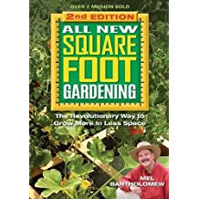
All New Square Foot Gardening II: The Revolutionary Way to Grow More in Less Space
Jan 1, 2013
by Mel Bartholomew

Paperback at Amazon.com $15.89

Kindle Edition at Amazon.com $10.76

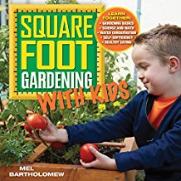
Square Foot Gardening with Kids: Learn Together: - Gardening Basics - Science and Math - Water Conservation - Self-sufficiency - Healthy Eating (All New Square Foot Gardening)
Mar 15, 2014
by Mel Bartholomew

Flexibound at Amazon.com $15.03
Kindle Edition $11.99

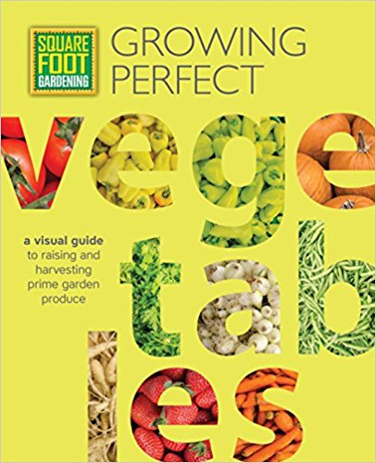
Square Foot Gardening: Growing Perfect Vegetables: A Visual Guide to Raising and Harvesting Prime Garden Produce (All New Square Foot Gardening)
May 8, 2017
by Mel Bartholomew Foundation

Paperback at Amazon.com $12.23
Kindle Edition at Amazon.com $9.99

